WELCOME
“SOON-TO-BE” KINDERGARTENERS

St. Dominic Academy Kindergarten
2023-2024 Supply List

Dear Kindergarten Parents:

Your child will need certain supplies in order to give him/her the best opportunity to learn and grow within the kindergarten program. We believe that the easiest, least expensive and least time consuming way for you to obtain these supplies and to ensure your child has the necessities, is to have all the supplies needed already available in the classroom. All the needed supplies will be available to your child on the first day of school. There will be a one-time cost of $40.00 for these supplies. Please send the $40.00 with your child on the first day of school.

Since all the supplies your child needs will already be in the classroom, the only things your child will need to bring on the first day of school are:

A full sized backpack with no wheels
$45.00 supply fee
Box of tissues
A large container of Clorox or Lysol brand wipes

Thank you! We look forward to seeing you in the fall! Sincerely,
The Kindergarten Team

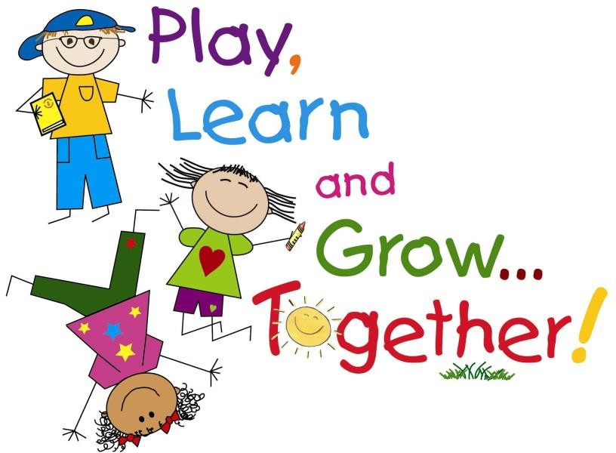

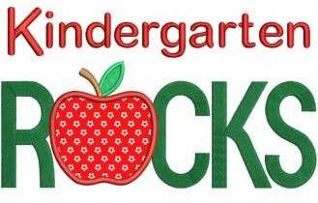
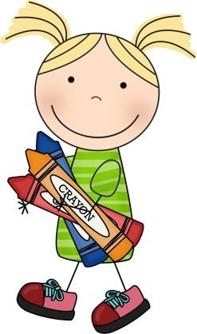
Now onto our FUN & LEARNING!!!
We are thrilled to have you become a
part of our St. Dominic Academy Kindergarten family!! As you enjoy your summer, at camps, on
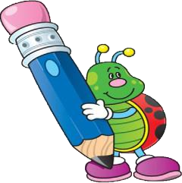
your swing set, at the beach or in your yard… Take a few minutes to practice your letters and letter sounds each day. Count your numbers on car rides – up-up- as high as you can! Take a
look at the book list that we have
attached and listen and read every day. Make sure to practice writing your name and the alphabet. We have also attached a little math
booklet for you to practice some of the things that you learned in Pre-K.
We hope you have fun this summer! We are excited to see you in August to begin your Kindergarten journey with you!

Your Kindergarten Teachers, Ms. Slonina & Miss Ferron

Reading List for Rising Kindergarteners Summer 2023
Recommended Reading:
☺ I Promise by LeBron James

Suggested Reading:
☺ The World Needs More Purple People by Kristen Bell
☺The Little Butterfly That Could by Ross Burach
☺ Corduroy by Don Freeman
☺I Don’t Want to Be a Frog by Dev Petty
☺ Don’t Let the Pigeon Drive the Bus by Mo Willems
☺ The Little Mouse, the Red Ripe Strawberry and the Big Hungry Bear by Don Wood
☺ Ricky, The Rock That Couldn’t Roll by Mr. Jay
☺ Duck in The Truck by Jez Alborough
☺ Animals Should Definitely Not Wear Clothing by Judy Barrett
☺ It’s Hard to Be Five by Jamie Lee Curtis
☺ Ten Little Fish by Audrey Wood
☺ If You Give a Mouse A Cookie by Laura Numeroff
☺ The Koala Who Could by Rachel Bright
☺ Elmer by David McKee
☺ Down to the Sea with Mr.Magee by Chris Van Dusen (Maine author)
☺ Moose, of Course by Lynn Plourde (Maine author)
☺ Dr. Seuss books
☺ Nursery Rhyme books
☺ Eric Carle books
☺ Clifford books
The books listed above are suggestions only – please feel free to visit the public libraries. We would encourage you to continue to read with your child every day through the summer months.
So read, relax, and enjoy your summer!
